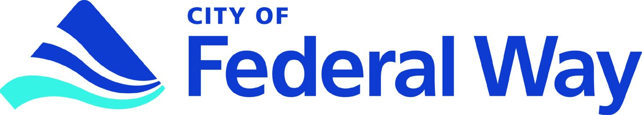
EMERGENCY HOUSING REPAIR PROGRAM
CONTRACTOR’S QUESTIONNAIRE

Contactor Name: |  |  |  |  |  |  | Phone:
Address: City, State, Zip
Email: |  |  |  |  | DUNS #

General Contractor Electrical Plumbing Exterior Painting Roofing
Ramps/Stairs Bathrooms Kitchens Other___________________________

Names and addresses of all company owners:
1)
2)

Federal Tax ID Number: |  |  |  |  |  |  |  |  |  |  | CFW Business License? |  |  | YES |  | NO
State of Washington License Number UBI #:
WA State Contractors License Number:
Are you registered on www.sam.gov website? ____ YES ____ NO (please provide a copy of proof)
Local Insurance Agent Co.
Policy No. |  |  |  |  |  |  |  |  |  |  | Phone #
Expiration: |  |  |  |  |  |  |  |  |  |  | Amount $
Property Damage Insurance Company:
Policy # |  |  |  |  |  |  |  |  |  |  | Phone #
Expiration No. |  |  |  |  |  |  |  |  |  |  | Amount $
Bonding Agent (if different)
Policy # |  |  |  |  |  |  |  |  |  |  | Phone #
Expiration No. |  |  |  |  |  |  |  |  |  |  | Amount $
LIST THREE (3) REHABILITATION PROJECTS (at least two (2) projects must be rehab work in an owner-occupied residential structure):

Name |  |  |  |  | Address, City, State, Zip
Phone |  |  | Amount $ |  |  |  | Date
Scope of work:

Name |  |  |  |  | Address, City, State, Zip
Phone |  |  | Amount $ |  |  |  | Date
Scope of work:

Name |  |  |  |  | Address, City, State, Zip
Phone |  |  | Amount $ |  |  |  | Date
Scope of work:

List the primary type of work you are qualified for and any other pertinent information (this information will be available to homeowners):

List any experience, training and/or certifications working with lead-based paint:

Type of business: Check all that apply
Minority Owned Women Owned Section 3 Emerging Small Business
Corporation Limited Liability Sole Proprietor Non Profit
Other:

Definition of business type:

Minority Owned Businesses (MBE)
Minority-owned business is a for-profit enterprise, regardless of size, physically located in the United States or its trust territories, which is owned, operated and controlled by minority group members. "Minority group members" are United States citizens who are Asian, Black, Hispanic and Native American.
Ownership by minority individuals means the business is at least 51% owned by such individuals or, in the case of a publicly-owned business, at least 51% of the stock is owned by one or more such individuals. Further, the management and daily operations are controlled by those minority group members.

Women Owned Businesses (WBE)
To become certified as a woman owned business, businesses must show:

- All prospective members must provide clear and documented evidence that at least 51% or more is women-owned, managed, and controlled.
- The business must be open for at least six months.
- The business owner must be a U.S. citizen or legal resident alien.

Section 3 Businesses
A business can qualify as a Section 3 business if:
- 51 percent of the business is owned by one or more Section 3 residents; or
- A minimum of 30 percent of its full-time employees are current (or qualified within three years of first employment with the business) as Section 3 residents; or
- It subcontracts in excess of 25 percent of all of its contracts to Section 3 businesses.

Emerging Small Business
A small business concern whose size is no greater than 50 percent of the numerical size standard applicable to the Standard Industrial Classification code assigned to a contracting opportunity.

I hereby certify that the above statements are true and correct to the best of my knowledge. I understand that a false statement will disqualify me from participating in the City of Federal Way’s Emergency Housing Repair Programs.

Signature |  | Printed Name
Date

