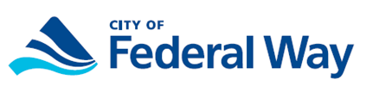
LOW INCOME AND/OR DISABLED
FEDERAL WAY CITIZENS

Senior Citizens:
If you are able to answer YES to questions 1-4, you may apply for a rebate of the utility taxes you paid in 2019.

- Do you live within INCORPORATED limits of Federal Way?
- Did you pay household utilities, which were in your name in 2019?
- Was the annual gross income of your household in 2019 less than the following:

People in Household |  | Maximum Annual Income
1 |  | $38,750
2 |  | $44,300
3 |  | $49,850
4 |  | $55,350
5 or more |  | Please call 253-835-2506

- Were you at least 65 years old in 2019?

Disabled Citizens:
If you are able to answer YES to questions 1-3 and question 5, you may apply for a rebate of the utility taxes you paid in 2019.

- Do you have a physical or mental disability as defined below?

A disabled individual is any person unable to maintain gainful employment because of his or her physical or mental disability (i.e. ability to work is diminished because of a physical or mental impairment). Applicants may be eligible for a rebate of their utility taxes for the period they were disabled.
Please call the City of Federal Way Utility Tax Rebate Line at
253-835-2506 or stop by City Hall (2nd floor-Finance)
Monday – Friday 8:00 a.m. – 5:00 p.m.
*******ALL PAPERWORK MUST BE RECEIVED BY TUES, APRIL 30, 2020*******

